Hazelbury Value | Rights Respecting Focus | Oracy Focus | Enrichment and Experiences
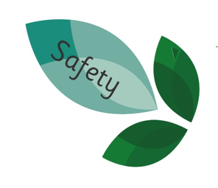 | 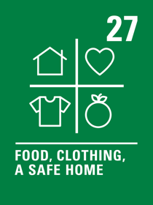 | 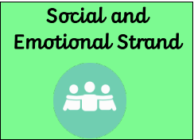 | - -Toscana Strings  - -Edmonton Green Library visits

 | Week One | Week Two | Week Three | Week Four | Week Five | Week Six | Week Seven
Literacy |   Text: The Distance Between Me and the Cherry Tree |  | 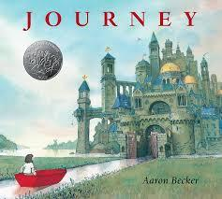  Text: Journey |  | Text: Percy Jackson: Lightning Thief  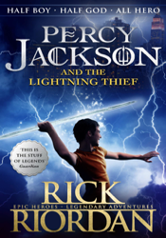 |  | 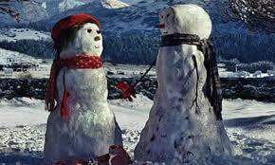  Visual Literacy
Literacy | Outcome: Descriptive narrative  Key word: adversity | Outcome: Narrative from another perspective  Key word: profess | Outcome: Narrative  Key word: Expedition | Outcome: Advert for magic crayon  Key word: Boundless | Outcome: Narrative  Key word: Ambrosial | Outcome: Non-chron report  Key word: Domain | Outcome- Narrative  Key word- Endure
Mathematics | Objective: Place Value  -Use negative numbers in context counting forwards and backwards  - To round numbers to the nearest 10,100  -To round nearest numbers 1000,10,000 100,00 | Objective: Decimals  -Recognise and use 1000ths and relate them to 10th and 100th  - To read and write decimals to 3 dp.  ⁻To compare and order decimals up to 3dp | Objective: Area and perimeter  -To calculate perimeter in cm and m  -To measure perimeter in cm and m  -To calculate and compare the area of squares and rectangles. | Objective: Fractions  -To compare and order fractions with the same denominator or multiples of the same number.  -To add fractions with the same denominator or multiples of the number.  -To subtract fractions with the same denominator or multiples of the number. | Objective: Angles  -To identify multiples of 90 degrees  -To identify reflex angles  -To compare different angles. | Objective: Statistics  -To read and interpret lines graphs  -To solve difference problems within a line graph.  -To read and interpret tables | Objectives: Reflection and Translation  -To identify the position and direction of a shape after reflection  -To identify and describe the position and direction of a shape after translation.
Science  Unit: Properties of Materials  Key Word:  Dissolve  Solutions  Reversable   | Lesson 1:  Objective  Compare and group together everyday materials based on their properties | Lesson 2:  Objective:  To know that some materials will dissolve in liquid to form a solution | Lesson 3:  Objective:  Use knowledge of solid, liquid and gas to decide how mixtures might be separated | Lesson 4:  Objective:  Demonstrate that dissolving, mixing and changes of state are reversible changes. | Lesson 5:  Objective:  Explain that some changes result in the formation of new materials and this kind of change is not usually reversible | Lesson 6:  Objective:  Give reasons based on evidence from comparative tests for the particular uses of everyday materials including metals, wood and plastic.
Geography/ History  Focus: -  What have Ancient Civilisations done for us? (Theme: Legacy)  Key Word:  Acropolis  Democracy  Hoplitodromos  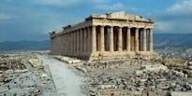 | Lesson 1:  Who were the Ancient Greeks? | Lesson 2:  Who were the Ancient Greeks? (Pt.2) | Lesson 3:  How did religion and gods influence Greek culture? | Lesson 4:  How did religion and gods influence Greek culture? (Pt.2) | Lesson 5:  What do artefacts tell us about what life was like in Ancient Greece? |  | Lesson 6:  What do artefacts tell us about what life was like in Ancient Greece? (Pt.2)
Art/DT  Unit: Coil pots (Grayson Perry)  Key Word:  Wedging  Sculpture  Coiling  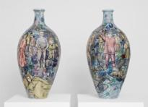 | Lesson 1:  How effective is Grayson Perry’s artwork? | Lesson 2:  How do artists influence others? | Lesson 3:  Why is it important to experiment with different materials, when creating a piece of art? | Lesson 4:  What are the benefits of using the coiling technique? | Lesson 5:  What are the benefits of using the coiling technique? | Lesson 6:  How do colours help to convey emotion? | Lesson 7:  How effective was your final piece?
PE  Unit: Gymnastics  Key words:  Asymmetric  Symmetric  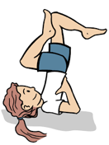 | Lesson 1:  Objective: To perform symmetrical and asymmetrical balances. | Lesson 2:  Objective: To perform interesting symmetrical and asymmetrical balances using apparatus. | Lesson 3:  Objective: To develop the straight, forward, straddle and backward roll. | Lesson 4:  Objective: To develop the straight, forward, straddle and backwards roll into a sequence. | Lesson 5:  Objective: To explore different travelling actions using both canon and synchronisation. | Lesson 6:  Objective: To explore different methods of travelling, linking actions in both canon and synchronisation.
PE  Unit: Netball  Key words:  Situation  Accelerate  Opposition  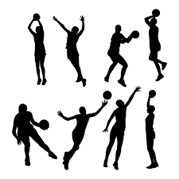 | Lesson 1:  Objective: To explore different passes and apply them to different situations. | Lesson 2:  Objective: To develop movement skills to lose a defender in different situations. | Lesson 3:  Objective: To communicate with my team, move into space and take the ball towards goal. | Lesson 4:  Objective: To defend an opponent and know when to try and intercept. | Lesson 5:  Objective: To develop the shooting action under pressure. | Lesson 6:  Objective: To use and apply skills, principles and tactics to a game situation. | Lesson 7:  Objective: To use and apply skills, principles and tactics to a game situation.
PSHE  Unit: Health & Wellbeing: Think Positive  Key words:  Cognitive  Mindfulness  Opportunities  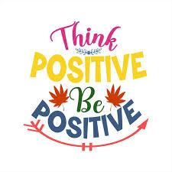 | Lesson 1: To understand the link between thoughts, feelings and behaviours.  Objective:  - To discuss and describe a range of thoughts, feelings  and behaviours.  - To discuss the impact unhelpful thoughts can have on ourselves  and others.  - To turn unhelpful thoughts into helpful thoughts. | Lesson 2: To understand the concept and impact of positive thinking.  Objective:  - To identify helpful and unhelpful thoughts.  - To name some strategies to deal with unhelpful thoughts.  - To generate positive affirmations. | Lesson 3: To recognise and manage uncomfortable feelings.  Objective:  - Describe and discuss a range of emotions.  - Understand how our feelings can impact on our thoughts and actions.  - Suggest strategies to cope with uncomfortable emotions. |  | Lesson 4: To understand the importance of making good choices.  Objective:  - Identify when a choice or decision needs to be made.  - Consider the consequences of different choices.  - Understand what it means to make an ‘informed decision’. | Lesson 5: To use mindfulness techniques in my everyday life.  Objective:  - Stop and focus on the here and now.  - Recognise when different mindfulness techniques might be useful.  - Understand how mindfulness can be linked to happiness. | Lesson 6: To apply a growth mindset in my everyday life.  Objective:  - Identify challenge as a positive thing.  - Overcome difficulties using a range of strategies.  - Understand the impact a positive attitude can have on my learning.
Computing  Unit: Video production (Value: Safety)  Key words:  Modify  Duplicate  Vector drawing   | Lesson 1: What is video?  Objective: To explain what makes a video effective. | Lesson 2: Filming techniques  Objective: To use a digital device to record video | Lesson 3: Using a storyboard  Objective: To capture video using a range of techniques | Lesson 4: Planning a video  Objective: To create a storyboard |  | Lesson 5: Importing and editing video  Objective: To identify that video can be improved through reshooting and editing | Lesson 6: Video evaluation  Objective: To consider the impact of the choices made when making and sharing a video
Music  Unit: Vikings  Key words:  Motif  Polyphonic  Structure   | Lesson 1:  To explore and organise rhythms using voice and instruments. | Lesson 2:  To organise rhythms into beats and notate them using 1, ½ and 2 beat notes. |  | Lesson 3:  To perform simple rhythms from music notation. | Lesson 4:  To compose and combine rhythms creatively to convey an intended effect. | Lesson 5:  To select and combine musical ideas to create an interesting and satisfying structure. | Lesson 6:  Objective:  To perform Viking compositions and offer feedback on recorded music and the music of my peers.
French  Unit:  Welcome back   | Lesson 1  I can ask and answer several questions about myself | Lesson 2  I can recall numbers to 10 and classroom instructions | Lesson 3  I can say and read some numbers between 0 and 20 | Lesson 4  I can remember days of the week and months of the year | Lesson 5  I can say and write the names of rooms in a school | Lesson 6  I can say and write nouns for some classroom objects | Lesson 7  I can record a conversation about classroom objects and classrooms in a school.
Religion and Worldview Day | Concept: Questioning what Christmas means to Christians.  KQ: Has the true meaning of Christmas been lost?


