Hazelbury Value | Rights Respecting Focus | Oracy Focus | Enrichment and Experiences
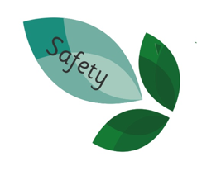 | 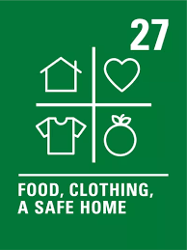 | 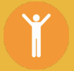  To begin to make eye contact with who we are talking to. | Rainbow Theatre Company

Week | Communication and Language and Literacy | PSED | Physical Development | Mathematics | Understanding the World | Expressive Arts and Design | Nursery Rhyme/Song
1 | Change Starts With Us  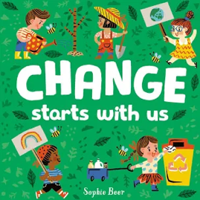  Key word: change | Working Together: Understand the importance of sharing  Mindfulness and Yoga: Candle Breathing | To copy and create shapes with your body. | To begin to understand that the number changes as we add and take away object. To recite number names in the correct order | To explore how we can care for the environment and each other. | To reuse materials to create something new. | Recycling Song
2 | Tidy  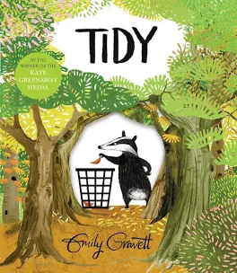  Key word: mistake | Working Together: Understand the importance of taking turns and sharing.  Mindfulness and Yoga: Candle Breathing | To be able to create shapes while on apparatus. | To know that if the numbers are said in the right order, the last number in the count defines the number of items in the set. (Cardinal principle). To count objects one to four using one to one correspondence and know that the total is four without recounting. | To explore different types of materials. | To create structures using natural materials. | Walking in the forest
3 | Tyranosaurus Drip  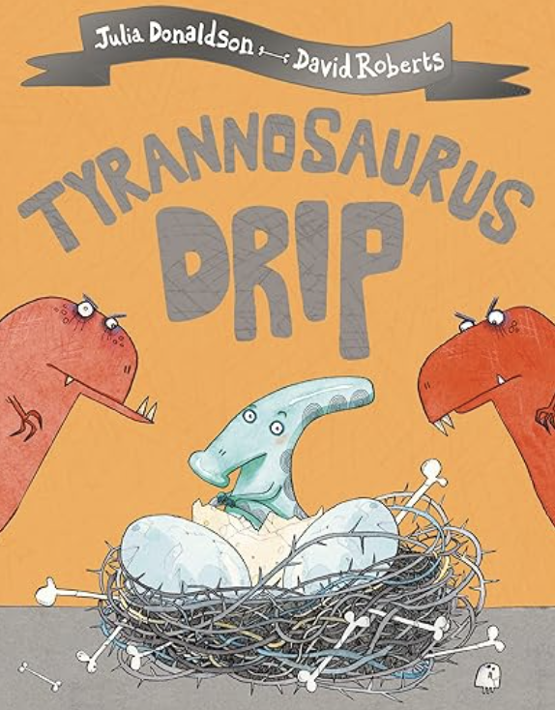  Key word: fierce | Working Together: Begin to understand the importance of teamwork.  Mindfulness and Yoga: Candle Breathing | To develop balancing and taking weight on different body parts. | To order Numberblocks one to five. To identify which Numberblock is missing. | To have an understanding of dinosaurs and their extinction. | To manipulate malleable materials into different representative forms. | Dinosaur Roar
4 | Dinosaurs love Underpants    Key word: roar | Working Together: Understand what kindness is and why it is important.  Mindfulness and Yoga: Candle Breathing | To develop jumping and landing safely. | To know how many, they have in a set of objects. One-to-one correspondence: – match one number name to each item to be counted. | To have an understanding of dinosaurs and their extinction. | To use early sewing techniques in a design. | A round of applause for the dinosaurs
5 | Troll: 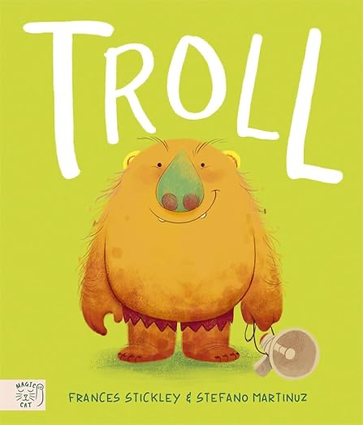  Key word: terrifying | Look what I can do: Practise getting dressed and undressed.  Mindfulness and Yoga: Candle Breathing | To develop rocking and rolling. | To know 2 and 4 can be partitioned into smaller numbers. | To have an understanding of different animal habitats. | To create props and use role-play to retell stories. | Three Billy Goats Gruff
6 | Hansel & Gretal  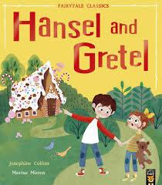  Key word: tricked | Look what I can do : Understand the importance of tidying up  Mindfulness and Yoga: Candle Breathing | To copy and create short sequences by linking actions together. | To know that by adding one to a quantity produces an amount that is a bigger/higher number. To begin to talk about what they are doing e.g. “I have four blocks” “One more block” “Now I have five blocks”. | To understand that people live in different types of houses. | To explore materials in baking and cooking. | 5 Currant buns
7 | Little Owl and the Christmas Star  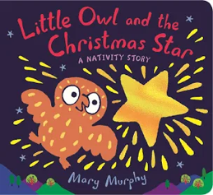  Key word: sparkle | Look what I can do: Follow Simple Instructions  Mindfulness and Yoga: Candle Breathing | To create sequences using apparatus. | Measure - To compare amounts of continuous quantities. | To begin to understand the season of Winter. | To use cutting and sticking techniques to create decorations. | Jingle Bells

