

- You should choose at least four of the eight options below to complete for your home learning project
- When you have completed a task, take a photo or video of your learning and upload this onto your Tapestry account for your teachers to see.
- There will be a ‘homework hero’ each half term in the class who will win a special reward!

Calculate or Reason | Play | Discuss | Create | Teach | Visit | Investigate | Watch or Listen
Explore subtraction facts to 4: Use real objects such as fruit, snacks or toys.  Example: You had 4 strawberries, you ate 1. How many are left?   | Dress up as pirates. Act out sailing, spotting treasure, and steering the ship.   | Discuss ways to look after your teeth and why this is important.   | Create a plant pot using recycled materials.   | Teach your family to read 10 high frequency words from your Phonics tin.   | Visit your local fire station  OR    Visit the library to find books about people who help us in our community. | 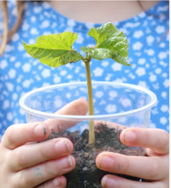  Plant your own seed and observe it growing over time. What does a plant need to grow? | Click here to watch and complete the yoga poses  
Hand in Date
Friday 15th May 2026


